Kinds of Networks

1. Introduction
A network is any collection of devices (hosts) connected so they can exchange data. Networks are commonly classified by scale, ownership, and purpose. The most frequently referenced categories are:

PAN — Personal Area Network
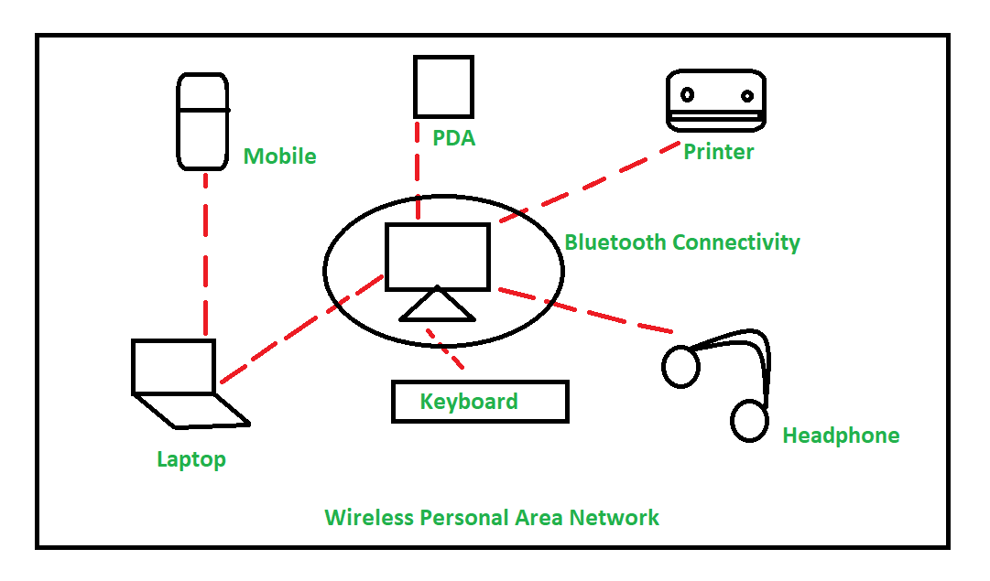
Definition: A PAN is a small network centered around one person/owner and their personal devices.
Typical range & tech: Up to a few meters. Bluetooth, USB, NFC, or a smartphone hotspot (Wi-Fi Direct).
Common devices: Smartphone, wireless earbuds, smartwatch, laptop, wireless mouse/keyboard.
Example (real world): Your phone paired with a smartwatch and wireless headphones while you stream music — that ecosystem forms a PAN.
When to use: Short-range personal connectivity for convenience and device synchronization.

LAN — Local Area Network
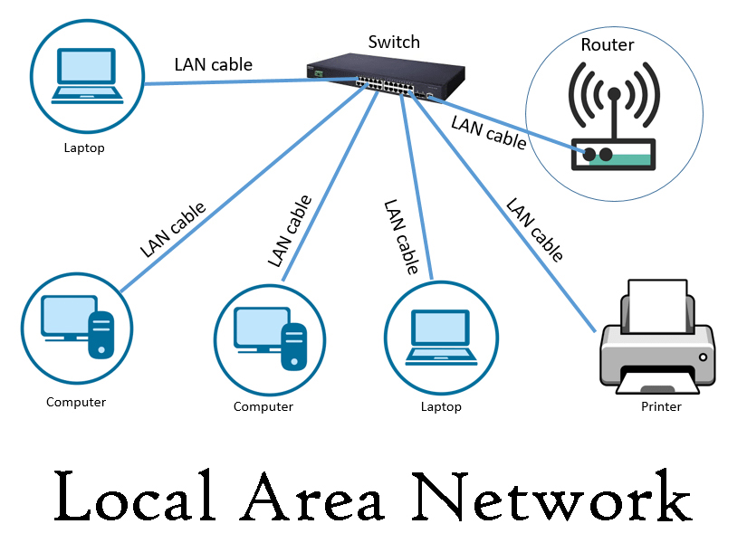
Definition: A LAN connects devices across a limited area such as a home, office, or single building.
Typical range & tech: From a single room up to a few kilometers. Ethernet (wired), Wi-Fi (wireless), and switches/routers are common.
Topology examples: Star (common — devices connect to a switch/router), Bus (legacy), and Hybrid.
Common devices: Desktop computers, printers, NAS (Network Attached Storage), Wi-Fi access points, VoIP phones.
Example (real world): An office floor where 50 computers share printers and an internal file server. The floor’s switch fabric and Wi-Fi access points create the LAN.
Design concerns: Throughput (GbE/10GbE), security (segmentation/VLANs), and resource sharing.

CAN — Campus Area Network
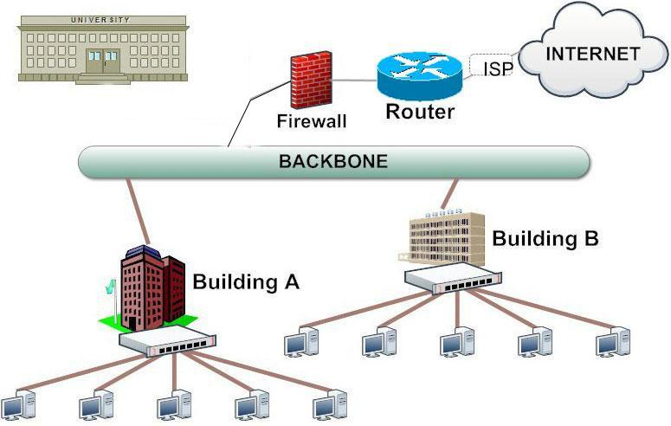
Definition: A CAN links multiple LANs within a limited geographic area such as a university campus, a corporate campus, or a military base.
Typical range & tech: Tens to hundreds of meters between buildings; fiber backbones are common with Gigabit or multi-Gbps links.
Use case: Connects several buildings, each with its own LAN, into a managed, larger network with centralized services (authentication, storage).
Example: A university connecting departmental networks, campus Wi-Fi, research labs and administrative offices into a single campus network with centralized data centers.
Design concerns: Backbone capacity, redundancy, inter-building security policies, and centralized management.

MAN — Metropolitan Area Network
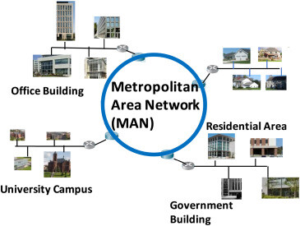
Definition: A MAN covers a city or a large campus area — bigger than a CAN, smaller than a WAN.
Typical range & tech: Several kilometers up to 100 km. Fiber optics, metro Ethernet, and microwave links.
Use case: City-wide networks provided by ISPs or used by large enterprises or municipal services.
Example: A municipal fiber ring that connects city government buildings, schools and public Wi-Fi zones.
Design concerns: Latency, SLA (service level agreements), and interconnection with ISPs and WANs.

WAN — Wide Area Network
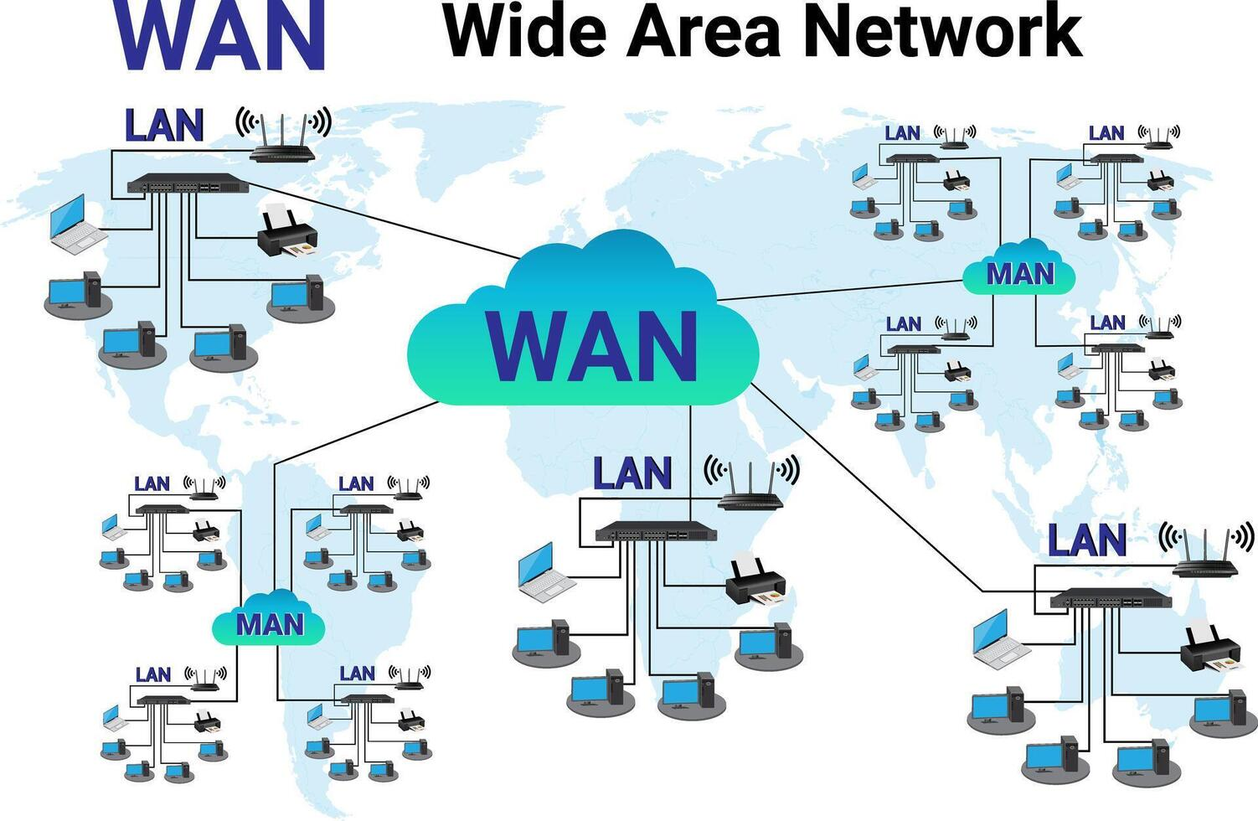
Definition: A WAN connects distant LANs and MANs across cities, countries or continents.
Typical range & tech: Intercity and international; uses leased lines, MPLS, SD-WAN, satellite, and undersea fiber cables.
Common devices: Routers, WAN accelerators, leased-line equipment and carrier interconnects.
Example (real world): A multinational company connects its regional headquarters in New York, London and Mumbai through an MPLS/SD-WAN fabric so applications across sites communicate securely.
Design concerns: Cost (leased circuits), routing policies, resilience across long distances, and latency.

SAN — Storage Area Network
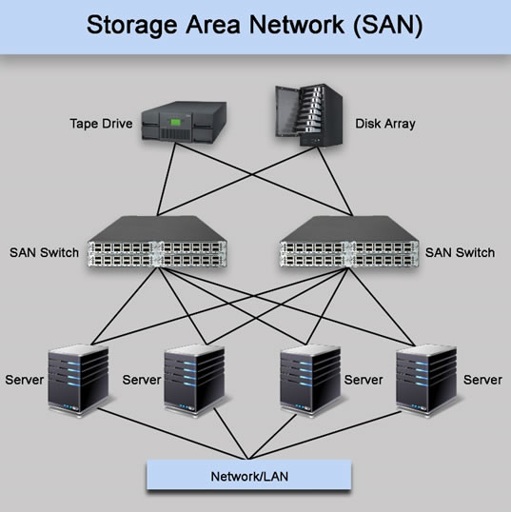
Definition: A specialized network that provides block-level access to consolidated, high-performance storage.
Typical range & tech: Usually within data centers; Fiber Channel, iSCSI over Ethernet, or NVMe over Fabrics.
Use case: Virtualization hosts and enterprise databases that require very fast, low-latency access to shared disk arrays.
Example: A data center where multiple servers access a centralized Fibre Channel array for database storage.
Design concerns: Throughput (multiple 16/32/64 Gbps FC links), redundancy, and data integrity.

VPN — Virtual Private Network
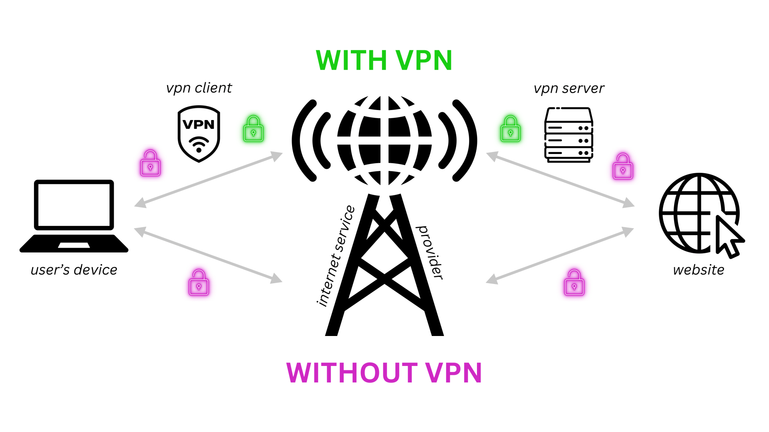
Definition: A VPN creates a secure “virtual” network over an untrusted physical network (like the Internet).
Typical use: Secure remote access for employees, site-to-site tunnels between branch offices, and encrypted overlays for cloud resources.
Example: A remote worker uses a VPN client to securely access corporate file servers as if they were on the corporate LAN.
Design concerns: Encryption overhead, authentication, and split tunneling policies.

